 | 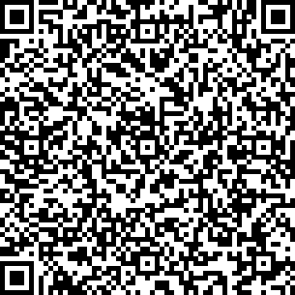 |  |  | 
GergelY d.o.o.  distribution and services  Vijenac Ivana Česmičkog 7  Osijek 31000, Croatia | GergelY d.o.o.  distribution and services  Vijenac Ivana Česmičkog 7  Osijek 31000, Croatia | GergelY d.o.o.  distribution and services  Vijenac Ivana Česmičkog 7  Osijek 31000, Croatia | GergelY d.o.o.  distribution and services  Vijenac Ivana Česmičkog 7  Osijek 31000, Croatia | GergelY d.o.o.  distribution and services  Vijenac Ivana Česmičkog 7  Osijek 31000, Croatia
Gergely rudolf  +385 95 800 8000  Email: info@gergely.hr  www.gergely.hr | Gergely rudolf  +385 95 800 8000  Email: info@gergely.hr  www.gergely.hr | Gergely rudolf  +385 95 800 8000  Email: info@gergely.hr  www.gergely.hr | Gergely rudolf  Street Address  Osijek, 31000, Croatia  +385 95 800 8000  Email: info@gergely.hr  www.gergely.hr | Gergely rudolf  Street Address  Osijek, 31000, Croatia  +385 95 800 8000  Email: info@gergely.hr  www.gergely.hr
 |  |  |  | 
GergelY d.o.o.  distribution and services  Vijenac Ivana Česmičkog 7  Osijek 31000, Croatia | GergelY d.o.o.  distribution and services  Vijenac Ivana Česmičkog 7  Osijek 31000, Croatia | GergelY d.o.o.  distribution and services  Vijenac Ivana Česmičkog 7  Osijek 31000, Croatia | GergelY d.o.o.  distribution and services  Vijenac Ivana Česmičkog 7  Osijek 31000, Croatia | GergelY d.o.o.  distribution and services  Vijenac Ivana Česmičkog 7  Osijek 31000, Croatia
Gergely rudolf  Street Address  Osijek, 31000, Croatia  +385 95 800 8000  Email: info@gergely.hr  www.gergely.hr | Gergely rudolf  Street Address  Osijek, 31000, Croatia  +385 95 800 8000  Email: info@gergely.hr  www.gergely.hr | Gergely rudolf  Street Address  Osijek, 31000, Croatia  +385 95 800 8000  Email: info@gergely.hr  www.gergely.hr | Gergely rudolf  Street Address  Osijek, 31000, Croatia  +385 95 800 8000  Email: info@gergely.hr  www.gergely.hr | Gergely rudolf  Street Address  Osijek, 31000, Croatia  +385 95 800 8000  Email: info@gergely.hr  www.gergely.hr

